THE STATUS OF TAX EDUCATION
AND THE AICPA MODEL TAX CURRICULUM

ABSTRACT

The AICPA proposed a Model Tax Curriculum in 1996 with the intent of fundamentally changing tax education. The proposed curriculum was updated and modified in 1999, again in 2006, and most recently in 2012.

In the fall of 1998, two independent surveys of tax educators were completed to determine whether the Model Tax Curriculum was being implemented at that time. Results of both surveys indicated that less than twenty percent of respondents used the Model Tax Curriculum at the time of the survey. Most schools required one tax course at the undergraduate level, generally consisting of individual taxation, while offering a second course covering other entities.

A survey modeled after the 1998 survey was administered in the fall of 2005, fall of 2009, and fall of 2015 to obtain data for longitudinal comparisons regarding the status of and changes in the Model Tax Curriculum (MTC) and tax education at colleges and universities across the United States. The surveys administered in 2009 and 2015 were developed to capture any changes resulting from the AICPA modification of its model tax curriculum in 2006 and 2014. Adoption of the MTC has remained at a steady rate (generally less 20% for the first tax course and 10% for the second tax course) over the last two decades.

INTRODUCTION

Federal tax education appeared to be on the verge of significant change in 1996. In 1995, the American Institute of Certified Public Accountants (AICPA) Tax Division Task Force developed a Model Tax Curriculum (MTC) to address the concerns expressed by employers that graduates should have a broader tax knowledge base to succeed in the current competitive business environment. The proposed new tax curriculum model was a fairly radical change in the content and timing of content delivery for federal tax education across the country. Since that time, however, there has been very little written relating to the proposed curriculum or the movement of tax educators toward the MTC, other than summaries and updates by various task force members. This paper discusses the proposed curriculum, and presents the results of nationwide surveys of tax instructors on the adoption of the AICPA Model Tax Curriculum since 1996.
ACCOUNTING EDUCATION

Accounting education has been the object of much scrutiny over the past several decades. Studies have been commissioned and conducted by academic and professional organizations. The Bedford Committee criticized accounting education for remaining essentially unchanged despite changes in business (AAA Committee on the Future Structure, Content, and Scope of Accounting Education, 1986). Albrecht and Sack’s report, Charting a Course through a Perilous Future (2000), served as a catalyst for improving the academic preparation of accountants by focusing on the development of knowledge, skills, and ethics. More recently, the Pathways Commission (Behn, et al., 2012), created by the AAA and AICPA, charted a national strategy for the next generation of accountants, recommending the creation of ‘curricular models for the future.’ In response, the joint IMA/AAA MAS Curriculum Task Force (Lawson, et al., 2014) tackled developing a comprehensive curricular model, defining competencies all accounting majors must have for long-run success such as communication, quantitative, analytical thinking, interpersonal, and technological skills. The task force also addressed the need for tax education, writing “all accountants much understand the basics of taxation to be able to assess tax impacts on decisions and to know to seek expert advice where appropriate” (Lawson, et al.,2014, p. 304). The task force believed that broad competencies in both corporate and personal taxes are essential for all accountants.

THE MODEL TAX CURRICULUM
Tax education has made a similar progression from the specific recommendations in 1986s to the broader recommendations of today. Because of the ever-growing complexity of the tax laws and tax practice as well as new technology, many individuals and groups have become concerned that traditional tax education was not keeping pace with tax practice in our rapidly changing and competitive business environment. As a result, the Executive Committee of the American Institute of Certified Public Accountants (AICPA) Tax Division created the Model Tax Curriculum Task Force. The original task force included members from public practice (Big Six [in 1995], regional, and large and small firms), private industry, and academia (Oppenheimer 1997). The goals of the Task Force were to evaluate tax education and develop specific recommendations for tax courses and programs at the undergraduate and graduate levels. The Task Force analyzed tax education based on a traditional model of two undergraduate tax courses, graduate tax programs (for both full-time students and part-time students with full-time jobs), and tax courses included in Masters in Accountancy and MBA programs (Journal of Accountancy 1994).

The typical undergraduate college tax curriculum has been an introductory course based on knowledge and application of the Internal Revenue Code as applied to individuals, followed by a second course covering the tax laws as applied to business and other entities. Many accounting programs require one tax course in the accounting curriculum, with the second course being an elective. In addition, because large accounting firms pushed for students to acquire non-technical skills, some schools dropped the second tax course (O’Neill, Weber, & Harris, 1999). The result of the emerging structure has been students being well prepared in individual taxation, but not adequately exposed to taxation of corporations, partnerships, or other entities (unless they took the second tax course in a graduate program).
The conclusion reached by the 1986 AICPA Model Tax Curriculum Task Force was that the graduate-level programs were sufficient in preparing students for their respective markets, but the first undergraduate tax course needed to change (Journal of Accountancy 1994). A detailed course outline, including objectives and content areas by hours of coverage, was developed for a first and a second tax course at the undergraduate level, and a tax course for an MBA program. Suggested curriculum content was also provided for a Masters of Accounting degree with a tax emphasis and a Master’s of Science in Taxation program (Journal of Accountancy 1994).
The recommendation of the 1986 Task Force was to structure a first undergraduate tax course to present an overview of the primary entities and issues encountered in practice. Since students may not take a second course, the Task Force reasoned this first course should introduce students to the topics considered to represent the minimum knowledge base upon which to build and prepare for employment (Oppenheimer 1997). These topics introduce taxation and basic research methods and include income, deduction and losses, and property transactions. In addition, the Task Force prescribed coverage of basic entity types including corporations, partnerships, and S corporations in the first course. The course would also include fringe benefits and retirement planning, computation of tax, and responsibilities in tax practice.
The second undergraduate tax course recommended by the Task Force augments the foundation material concerning entities in the first course by continuing with formation, operation, and ending of the basic entity types, including limited liability entities. Topics also include coverage of estate and gift tax, trusts, tax exempt entities, alternative minimum tax, financial accounting concepts, multi-jurisdictional issues, employee compensation, related parties, tax planning, and ethics (AICPA, 1995).
The most striking difference between the MTC and the more traditional first course is the concentration on all primary entities rather than individuals. Because of increased coverage of entities, the depth of coverage is obviously limited, which was the intention of the Task Force (Oppenheimer 1997). The second tax course, although revised, may not be very different from how many programs traditionally offer the course. Although no attempt was made to specify methodology used to disseminate the information, the Task Force strongly recommended development of oral and written communication, critical problem solving, interpersonal skills, use of technology, business and professional ethical considerations, team building, and research and planning. The Task Force was also very specific in recommending six semester hours of tax education for all undergraduate accounting majors (AICPA, 1995).
In 2007, another joint task force was put together, and they revised the MTC to focus on learning outcomes rather than course specifics. The task force recognized that there could be many paths to competencies and developing tax competencies should not be restricted to one or two tax courses (Dennis-Escoffier, Kern, & Rhoades-Catanach, 2009). Thus, the newer MTC integrated the AICPA core competencies via a matrix with tax learning outcomes (Dennis-Escoffier, et al., 2009). The 2007 MTC did lay out some basic competencies that students should master such as the ability to differentiate types of tax bases, apply reasoning tools to entity taxation, analyze book and tax differences, demonstrate research and communication/interpersonal skills, and appreciate ethical obligations to the community.
In 2012, a joint task force of the AICPA and American Tax Association (ATA) convened to revisit the MTC. The MTC task force represented various constituencies interested in tax education. The Task Force wanted to present a “model” document that would serve as a starting point for curricular discussions, and not to present a “one-size-fits-all” model (Purcell, et al 2014). In 2014, a new MTC was published. In this model, the task force clarified learning objectives according to Bloom’s taxonomy, restructured learning objectives, expanded discussion of content expectations, and gave sample syllabi (AICPA Tax Section, 2014).

THE STATUS OF TAX EDUCATION
Given the many task forces over the last two decades, accounting programs have been in a position to modify their curricula by adopting the recommended models, retaining the traditional model, or developing a custom model. One survey of practitioners revealed that graduates of masters programs appear to possess the skills necessary for the workforce (Dresank & Briggs, 2002). One the other hand, Schnee (2002) found that new hires with only a bachelor’s degree were deficient in their technical knowledge. Again, this seems to verify the thoughts of the task force that if one accounting course is required by programs, the content coverage needs to be different from the traditional model.
Academe appears to be resistant to change or, at best, very slow in the process of change. Give the three task forces since 1996, the researchers wondered if accounting programs were changing their programs to meet MTC guidelines. In order for tax education to advance, it is important to know what tax educators are doing and in what direction trends are moving. To meet those needs, the researchers have studied the implementation of the MTC over the last 20 years.

TAX RESEARCH QUESTIONS
Tax educators have had two decades to implement change in their curricula. In 1996, the MTC caused conversations among educators and textbook representatives. Researchers wondered if there an immediate surge to adopt the MTC. The first survey was administered three years after the release of the recommendation giving tax professors three years to implement a change.
Research Question 1: Three years after the release of the recommendation, do the first tax classes demonstrate a preference for the AICPA Model Tax Curriculum over the traditional individual tax model.

Research Question 2: Three years after the release of the recommendation, do the second tax classes demonstrate a preference for the AICPA Model Tax Curriculum over the traditional entities tax model.

In academe, change can occur slowly. Therefore, it is not overly surprising if the Model Tax Curriculum was not heavily adopted within the first short three-year time period. As more materials consistent with the Model Tax Curriculum such as textbooks become available, adoption becomes easier to do. To better assess the extent of the movement toward implementation of the MTC, a longer time period was examined. To give tax educators sufficient time, adoption rates were again examined ten years after the MTC recommendation.
Research Question 3: Ten years after the release of the recommendation, do the first tax classes demonstrate a preference for the AICPA Model Tax Curriculum over the traditional individual tax model.

Research Question 4: Ten years after the release of the recommendation, do the second tax classes demonstrate a preference for the AICPA Model Tax Curriculum over the traditional entities tax model.

In 2007, the AICPA revised its MTC. The model became less prescriptive in content, and more tied to learning objectives. Perhaps this new orientation would capture the attention of accounting programs that had not adopted the MTC. Given an additional three years, revision adoption rates are again examined to determine if more accounting programs adopted the MTC.
Research Question 5: Three years after the 2006 revision, fourteen years after the release of the initial recommendation, do the first tax classes demonstrate a preference for the AICPA Model Tax Curriculum over the traditional individual tax model.

Research Question 6: Three years after the 2006 revision, fourteen years after the release of the initial recommendation, do the second tax classes demonstrate a preference for the AICPA Model Tax Curriculum over the traditional entities tax model.

In 2014, the AICPA again revised its MTC restructuring learning objectives and adopting Bloom’s taxonomy of learning. These new structural changes again were made to attract accounting programs that had not yet adopted the curriculum model. Again, revision adoption rates are examined to determine if more accounting programs adopted the MTC.
Research Question 7: One year after the 2014 revision, twenty years after the release of the initial recommendation, do the first tax classes demonstrate a preference for the AICPA Model Tax Curriculum over the traditional individual tax model.

Research Question 8: one year after the 2014 revision, twenty years after the release of the initial recommendation, do the second tax classes demonstrate a preference for the AICPA Model Tax Curriculum over the traditional entities tax model.

Given the changes in the orientations of the MTC and in accounting education as a whole, one would think that tax education community would adopt the changes at an increased rate. While the number of accounting programs that have adopted the MTC may not be great in the early years, there could be an increase in adoptions in more recent years. Over time, given the reports by the Pathways Commission and the IMA task force, resistance to change should lessen. There should be improvement in the adoption rates.
Research Question 9: Adoption rates for the AICPA Model Tax Curriculum in the first class have increased over time after the release of the recommendation.

Research Question 10: Adoption rates for the AICPA Model Tax Curriculum in the second class have increased over time after the release of the recommendation.

METHODS
Researchers collected data using four surveys. The surveys included the same questions but were administered in 1998, 2005, 2009, and 2015. The first survey was distributed and collected by mail the fall of 1998, three years after the recommendation of the AICPA Tax Model Curriculum. The second survey was collected through an internet survey site during the fall of 2005, 10 years after the recommendation. The third survey also was collected through the internet during the fall of 2009, 14 years after the initial recommendation and three years after a revision to the model curriculum. The fourth survey was collected through the internet survey site during the fall of 2015, 20 years after the initial recommendation and one year after a second revision to the model curriculum. Data from an additional survey, collected during 1998, was used to validate the survey.
Initial Survey (1998)
Researchers developed and administered a mail survey instrument (see Appendix A) to gather the opinions of tax educators relating to the tax curriculum currently in place at their institutions. To increase the likelihood that the survey would be completed and returned, the survey instrument was intentionally limited to one side of one page. Participants were advised that it would take no more than ten minutes to complete the questionnaire. To conserve space on the questionnaire, demographic information was requested at the bottom of the cover letter. The instrument was pre-tested by faculty in tax and other areas, and after several iterations, was prepared for mailing.
The questionnaire asked specific questions concerning the number and content of the tax courses offered at the respondent’s institution. Inquiries were also made regarding projects and/or outside assignments required in the tax courses, such as tax returns prepared manually or using a computer package, internet projects, and tax research (using print, CDs, or online services). Finally, respondents were asked if they were currently using the AICPA Model Tax Curriculum, when it was adopted or would be adopted, or if not currently using the Model Tax Curriculum, why not?

Using James R. Hasselback’s 1998 Accounting Faculty Directory as the primary source of names for inclusion in the initial survey, tax educators were contacted. Researchers selected one person designated as teaching tax (the first name listed) from each four-year college or university in the United States. Instructions also specified that the questionnaire could be given to another tax person at their college/university, as long as a tax professor was from that school. Researchers sent 695 subjects the survey. Respondents were asked to return both the cover letter (containing demographic information) and the questionnaire by fax or by mail in an addressed, postage-paid envelope.
All usable responses were received (the majority by mail) during the fall 1998 semester. Tallies were completed, frequency distributions were prepared, and percentages were calculated. Comments to questions were also recorded. Chi square tests were used to identify significant differences in responses.
Telephone Survey (1998)
A concurrent, independent survey was used to validate the initial mail survey document. The publisher, CCH, conducted a survey via telephone with a stratified sample of 38 educational institutions. Most of the survey involved topical coverage of interest to the publisher in regards to decisions about text publication. Several questions were pertinent to this article:
Are you currently following the AICPA Model Curriculum?
Are you planning to adopt the Curriculum?
Why have you chosen not to follow the AICPA Curriculum?
What motivated your adoption of the AICPA Model?
Second Survey (2005)
A web version of the initial mail survey (see Appendix B) was completed during the fall of 2005. The questions asked were the same as those asked on the initial survey, but there were differences in format resulting from using an on-line survey site. The cover letter was sent by email with a link to the internet site of the survey. The cover letter followed the wording of the initial cover letter as closely as possible, allowing for the differences in administration date and format of survey.
As with the initial survey, tax educators received the survey, but this time using James R. Hasselback’s 2005 Accounting Faculty Directory as the primary source of names. The same instructions were given. Researchers sent 806 subjects the link to the survey. All usable responses were received by the end of the fall 2005 semester.
Adoption rates for the AICPA Model Curriculum were compared between the two 1995 surveys and between the 1998 and 2005 surveys. Chi square tests were used to identify significant differences in responses. Overall adoption rates were examined as well as adoption rates within demographic categories.
Third Survey (2009)
Another web survey (see Appendix C) was completed during the fall of 2009. The questions asked were the same as those asked on the other two surveys. There was some minor difference in appearance resulting from improvements by the on-line survey service. An almost identical cover letter to that used for the second survey was sent by email with a link to the internet site of the survey.
As with the other two surveys, tax educators received the survey, but this time using James R. Hasselback’s 2008-2009 Accounting Faculty Directory as the primary source of names for inclusion in the survey. The same instructions were given. Researchers sent 858 subjects the survey link. All usable responses were received by the end of the fall 2009 semester.
Adoption rates for the AICPA Model Curriculum were compared between the 1998, 2005 and 2009 surveys. Chi square tests were used to identify significant differences in curriculum preferences and changes in adoption rates.
Fourth Survey (2015)
Another web survey (see Appendix C) was completed during the fall of 2015. The survey and email letter were identical to the prior survey.
As with the other three surveys, tax educators received the survey, but this time using James R. Hasselback’s 2014-2015 Accounting Faculty Directory as the primary source of names for inclusion in the survey. Researchers sent the survey link to 805 tax educators. All usable responses were received by the end of the fall 2015 semester.
Adoption rates for the AICPA Model Curriculum were compared between the 1998, 2005, 2009 and 2015 surveys. Chi square tests were used to identify significant differences in curriculum preferences and changes in adoption rates.

RESULTS
Research Questions 1 and 2
On the initial survey in 1998, 18.42% of the respondents reported using the AICPA model; 70.53% reported using the more traditional curriculum of individual taxation for their first tax class. A Chi Square test of preference (Χ² = 117.601, df = 2, p< 0.001) reveals a strong preference of one tax curriculum model over the others. Visual inspection shows that the traditional model of individual taxation was greatly preferred over the AICPA model for a first tax class (Table 1).

*** Insert Table 1 about here ***

On this survey, only 9.8% of the respondents with a second tax class reported using the AICPA Model Tax Curriculum and 75.16% reported using a traditional entities tax class. A Chi Square test of preference (Χ² = 118.603, df = 2, p<0.001) confirms a strong preference for one of the tax curriculum models over the others. Visual inspection shows that the traditional entities model was substantially preferred over the AICPA model for a second tax class (Table 2).

*** Insert Table 2 about here ***

Research Questions 3 and 4
In 2005, only 20.96% of the respondents reported using the AICPA model: 67.69% reported using an individual taxation course for the first tax class. A Chi Square test of preference (Χ² = 122.726, df = 2, p<0.001 confirms a preference for one of the tax curriculum models over the others. Visual inspection shows that the traditional model of individual taxation was preferred over the AICPA model for a first tax class (Table 1).
On the 2005 survey, only 10.24% of the respondents reported using the AICPA Model Tax Curriculum; 69.86% reported using a traditional entities tax class in a second tax class. A Chi Square test of preference (Χ² = 127.630, df = 2, p<0.001). This result demonstrates a significant preference for one of the tax curriculum models. Visual inspection shows that the traditional entities model was preferred over the AICPA (Table 2).
Research Questions 5 and 6
In 2009, only 16.74% of the respondents reported using the AICPA model; 71.49% reported using an individual taxation course for the first tax class. A Chi Square test of preference (Χ² = 143.359, df = 2, p<0.001 confirms a preference for one of the tax curriculum models over the others. Visual inspection shows that the traditional model of individual taxation was preferred over the AICPA model for a first tax class (Table 1).
On the 2009 survey, only 6.11% of the respondents reported using the AICPA Model Tax Curriculum; 83.33% reported using a traditional entities tax class in a second tax class. A Chi Square test of preference (Χ² = 200.049, df = 2, p<0.001). This result demonstrates a significant preference for one of the tax curriculum models. Visual inspection shows that the traditional entities model was preferred over the AICPA (Table 2).

*** Insert Figure 1and 2 about here ***

Research Questions 7 and 8
In 2015, only 14.81% of the respondents reported using the AICPA model; 74.07% reported using an individual taxation course for the first tax class. A Chi Square test of preference (Χ² = 159.344, df = 2, p<0.001 confirms a preference for one of the tax curriculum models over the others. Visual inspection shows that the traditional model of individual taxation was preferred over the AICPA model for a first tax class (Figure 1).
On the 2015 survey, only 7.78% of the respondents reported using the AICPA Model Tax Curriculum; 76.05% reported using a traditional entities tax class in a second tax class. A Chi Square test of preference (Χ² = 136.325, df = 2, p<0.001). This result demonstrates a significant preference for one of the tax curriculum models. Visual inspection shows that the traditional entities model was preferred over the AICPA (Figure 2).
Research Questions 9 and 10
Researchers analyzed changes in adoptions rates of the AICPA Model Tax Curriculum by comparing the adoption rates reported on all four of the surveys from 1998, 2005, 2009, and 2015. For the first tax class on the 1998 survey, 18.42% of the respondents reported using the AICPA model and 70.53% reported using individual taxation classes. On the 2005 survey, 20.96% of the respondents reported using the AICPA model for their first tax class and 67.69% reported using individual taxation classes. On the 2009 survey, 16.74% of the respondents reported using the AICPA model for their first tax class and 71.49% reported using individual taxation classes. On the 2015 survey, 14.81% of the respondents reported using the AICPA model for their first tax class and 74.07% reported using individual taxation classes. A Chi Square test of proportions (Χ² = 3.735, df = 6, non-significant) demonstrates no significant change in the percentage of institutions adopting the Model Tax Curriculum (Table 1, Figure 1).
For the second tax class on the 1998 survey, 9.8% of the respondents reported using the AICPA Model Tax Curriculum and 75.16% reported using a traditional entities tax class. On the 2005 survey, 10.24% of the respondents with second tax classes reported using the AICPA Model Tax Curriculum and 69.28% reported using a traditional entities tax class. On the 2009 survey, 6.11% of the respondents with second tax classes reported using the AICPA Model Tax Curriculum and 83.33% reported using a traditional entities tax class. On the 2015 survey, 7.78% of the respondents with second tax classes reported using the AICPA Model Tax Curriculum and 76.05% reported using a traditional entities tax class. A Chi Square test of proportions (Χ² = 10.073, df = 6, p>0.10) demonstrates a non-significant change in the percentage of institutions adopting the Model Tax Curriculum. A further inspection of the changes of adoption rates over time was made viewing the change from 1997 to 2005 (χ² = 0.0125, df = 2, non-significant) and the change from 2005 to 2009 (χ² = 6.6946, df = 2, p<0.05).
A visual inspection of the rate changes from 2005 to 2015 shows that usage rate of the traditional entities model slightly increased while the usage rate of the AICPA model slightly decreased over that time period. Therefore, the adoption rates for the AICPA model curriculum are not increasing (Table 2, Figure 2).
Survey Validity
Since the survey is not measuring a complex, abstract construct, the face validity of the surveys is high. The questions are simple and clearly stated as determined by pretests of local faculty. To further confirm the validity of the survey, convergent validity was established comparing the adoption rates from two independent surveys; the adoption rate for the first tax class as measured by the initial mail survey was compared to the adoption rate measured by an independent, telephone survey. The initial survey’s adoption rate was 18.42% (35 of the 190 schools.) The adoption rate for the first tax class as measured by the CCH telephone survey, also done in 1998, was 18.42% (7 of the 38 schools.) Without statistical tests, the conclusions are that the independent telephone survey obtained a result so similar it is concluded that these two surveys are measuring the same attribute–adoption of the AICPA Model Tax Curriculum.
The respondents of the first two surveys are considered similar based on two examinations. First, the response rates between the first two surveys, 27.50% for the mail survey and 28.41% for the web survey, were not significantly differ at any reasonable level, χ² = 0.113, df = 2. Examining all four response rates demonstrates very similar results--27.50%, 28.41%, 29.84%, and 26.83% with a non-significant χ² = 2.3032, df = 6.
*** Insert Table 3 about here ***

Second, comparisons were made on eight demographics of the respondents between the two surveys (Robson & Shaffer, 2007). Three of the demographic variables demonstrated significant differences between the 0.05 and 0.10 levels, a decrease in the number of tax professors, a decrease in the number of tax classes offered, and an increase in the highest type of degree conferred. These demographics were also reflected in the populations from which the respondents came, the entire population of schools reported in the two Accounting Faculty Directories.
The unit of analysis in this study was accounting programs. An argument may be advanced that larger programs more readily adopt the model curriculum thereby exposing more students to the model curriculum. Adoption rates for the size of accounting programs were compared (see Table 4). Even though larger programs do have higher adoption rates, the largest programs had adoption rates of less than 25% and consisted of a small percentage of the total departments. Therefore, while an analysis based on the number of accounting students rather than programs may slightly mitigate the severity of the discrepancy, it would still demonstrate a considerable lack of adoption of the MTC.

*** Insert Table 4 about here ***

CONCLUSION AND IMPLCATIONS FOR PRACTICE
The results of the surveys of tax educators from all types and sizes of institutions indicate that although the MTC has been adopted only by a minority of them in higher education. A sizable majority of tax educators continue to use the traditional curriculum for tax education. There appeared to be a very modest movement toward the curriculum between 1995 and Fall 1998, but that movement reversed and further diminished by Fall 2015. While higher education is slow in adapting to change, there has been very little if any continued increase in implementation rates of the MTC through Fall 2015. Educators are not adopting MTC despite the changes in approaches (e.g. adding emphasis on learning outcomes) over the last few years.
Tax educators that adopted the MTC gave several reasons. First, the recommendations made sense and second, it addressed the needs of employers. Several using the MTC noted they had been using it for years, or had developed a similar approach before it was called the Model Tax Curriculum.
Divergent tax educators cited reasons for not adopting the MTC. First, they disagreed with the concept of the newer curriculum, or second, textbooks were not currently available to support the new model. Yet, as more text books that supported MTC became available, adoption of the AICPA model did not significantly increase. Although most tax educators had at least a general awareness and had given it some consideration, some tax educators had not heard of the MTC and/or had no idea what it was. The greatest percentage of responses indicating a lack of knowledge about the MTC were on the 2015 survey.

*** Insert Table 5 about here ***

Educators had opinions about the traditional approach and the newer MTC. A fairly large percentage of respondents feel strongly that the traditional curriculum is a superior teaching approach to the MTC for various reasons as shown in Table 5. This attitude against adoption is still strong at 42% in 2015. The CPA exam may also continue to play a role in shaping curricula. Although tax instructors do not usually teach the exam, as long as individual taxation comprises a large part of one section of the exam, instructors believe there needs to be adequate coverage of the individual tax material, and this is not stressed in the MTC.
This research addresses the MTC and influence on the practice of teaching tax over two decades. Although by no means conclusive, the data revealed that tax educators as a whole are not adopting (or even aware) of the MTC. This presents a challenge to the AICPA and other groups interested in advancing tax education.
For change to take place, faculty training is probably needed. For example, Stout, Wygal, and Hoff (1990) found that faculty members who participated in a year-long training program, enhanced the writing and oral communication skills of their accounting students. Bacon, Paul, Johnson and Conley (2008) found that training helped marketing faculty overcome their lack of confidence in teaching basic writing to students. Thus, for the MTC to catch on, training is likely needed on a national level. We recommend various accounting education associations, such as the ATA and the AICPA, consider offering workshops at conferences to introduce more faculty members to the MTC to encourage dialogue and adoption of the MTC.
Acknowledgements:

Thanks to Patrick Cummings of CCH for his efforts with a telephone survey.
REFERENCES

Albrecht, W. S., & Sack, R. J. (2000). Accounting education: Charting the course through a perilous future (Vol. 16). Sarasota, FL: American Accounting Association.

American Accounting Association (1986). AAA Committee of the Future Structure, Content, and Scope of Accounting Education, The Bedford Committee.
American Institute of Certified Public Accountants (AICPA). 1995. Model Tax Curriculum Endorsed. Accounting Educators: FYI, 6 (May): 1,3.

__________. (1995). Model Tax Curriculum.

__________. (2007). Model Tax Curriculum.

__________. (2014). Model Tax Curriculum.
Bacon, D. R., Paul, P., Johnson, C. & Conley, T. (2008). Improving writing through the marketing curriculum. Journal of Marketing Education, 30(3), 217-225.
Behn, B. K., Ezzell, W.F., Murphy, L. A., Rayburn, J. D., Stith, M.T. & Strawser, J. R., (2012). The Pathways Commission on Accounting Higher Education: Charting a national strategy for the next generation of accountants. Issues in Accounting Education, 27(3), 595-600.
Dennis-Escoffier, S., Kern, B., & Rhoades-Catanach, S. (2009). The Revised Model Tax Curriculum. Issues in Accounting Education 24(2): 141-156.

Dresnack, W. H. & Briggs, G.P. (2002). Tax Education: AICPA MTC in Graduate Accounting Programs. The Tax Advisor 33(11).

Fisher, C. M. & Rupert, T. J. (2005). Fining Tax Policy into Tax Curricula. The Tax Advisor 36(11) 704-707.

Hasselback (1998). Accounting Faculty Directory, on disk.

Journal of Accountancy. (1994). A Tax Division Drafts Model Tax Curriculum.@ 178 (October): 104-109.

Lawson, R.A., Blocher, E.J., Brewer, P.C., Cokins, G., Sorensen, J.E., Stout, D.E., Sundem, G.L, Wolcott, S.K., & Wouters, M.J.F. (2014). ‘Focusing accounting curricula on students’ long-run careers: Recommendations for an integrated competency-based framework for accounting education,’ Issues in Accounting Education, 29(2), 295-317.

O’Neil, Cherie J. (1999). Assessing the Impact of the AICPA Model Tax Curriculum on the First Tax Course Taught at AACSB-accredited institutions. The Tax Advisor 30(8) 596-600.

Oppenheimer, J. S. (1997). The Model Tax Curriculum—Tax Education for the 21st Century. The Tax Adviser 28 (May): 322-323.

Purcell III, T., Nichols, N. Rhoades-Catanach, S. Rubin, J. T., Sawyers, R.B. & Spilker, B. (2014), The Model Tax Curriculum: 2014 Revisions Provide a Valuable Tool for Accounting Programs. The Tax Adviser. See more at: http://www.thetaxadviser.com/issues/2014/aug/c2c-aug2014.html#sthash.rF5d4FpU.dpuf

Robson, G. S. & Shaffer, R. J. (2007), From Snail-Mail to E-Mail: Comparability of Survey Format, Working Paper.
Schnee, E. (2002). Evaluating tax education: a survey of new hires. The Tax Adviser (August): 540-544.
Stout, D., Wygal, D. & Hoff, K. (1990). Writing across the disciplines: Applications to the accounting classroom. Bulletin of the Association for Business Communication, LIII (4), 10-16.

Appendix A

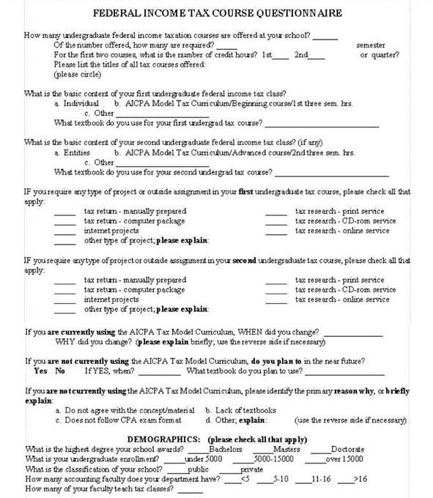

Appendix B

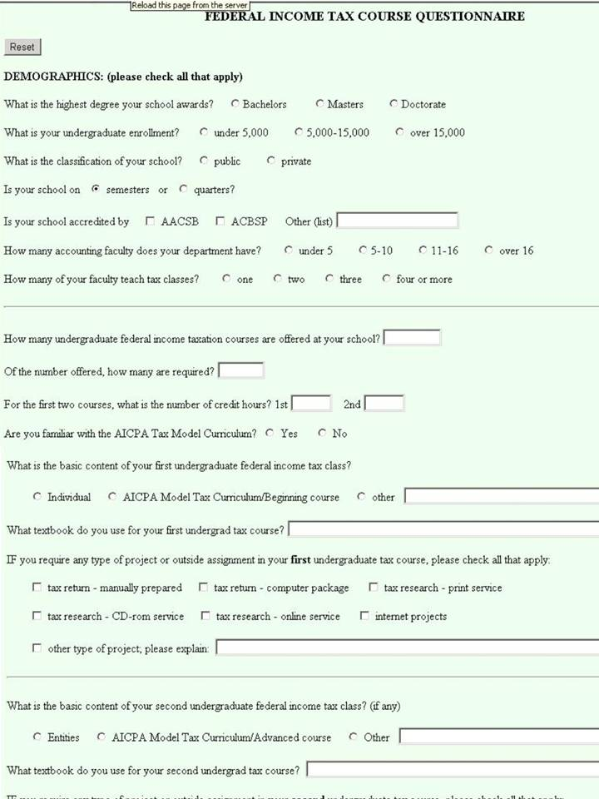
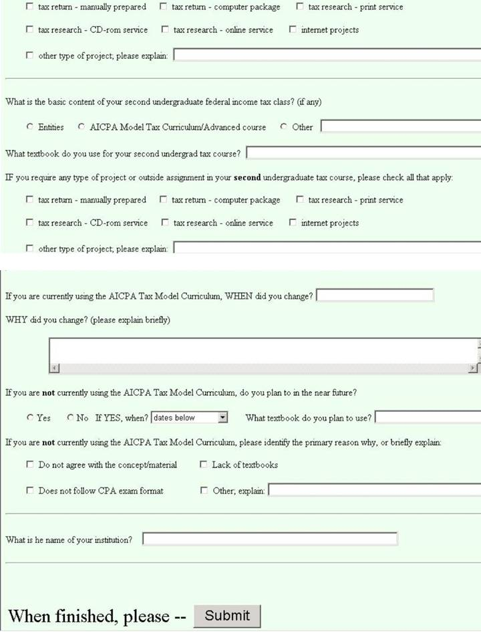
Appendix C

Indiv: teach individual taxation in the first course; ATM: teach MTC; Other: teach another method

Entities: teach entity taxation in the second course; ATM: teach MTC; Other: teach another method

Table 1. Adoption Rates for First Undergraduate Tax Classes
First tax course: | Individual taxation | AICPA Model | test of preference
1998 (190 schools) | 70.53% | 18.42% | χ² = 117.601 ***
2005 (229 schools) | 67.69% | 20.96% | χ² = 122.726 ***
2009 (125 schools) | 71.49% | 16.74% | χ² = 143.359 ***
2015 (214 schools) | 74.07% | 14.81% | χ² = 159.344 ***
test of change in preference χ² = 3.735
_____________________
*, **, *** Significant at 0.10, 0.05, 0.01, respectively.

Table 2. Adoption Rates for Second Undergraduate Tax Classes
Second tax course: | Entities | AICPA Model | test of preference
1998 (153 schools) | 75.16% | 9.80% | χ² = 118.603 ***
2005 (166 schools) | 69.28% | 10.24% | χ² = 96.977 ***
2009 (102 schools) | 83.33% | 6.11% | χ² = 200.046 ***
2015 (166 schools) | 76.05% | 7.78% | χ² = 136.325 ***
test of change in preference χ² = 10.073
_____________________
*, **, *** Significant at 0.10, 0.05, 0.01, respectively.

Table 3. Response Rates to Surveys
1998 Survey | 27.50% | χ² = 2.3032
2005 Survey | 28.41%
2009 Survey | 29.84%
2015 Survey | 26.83%
*, **, *** Significant at 0.10, 0.05, 0.01, respectively.

Table 4. 2009 Adopt rates (1st Course) for different Accounting Department sizes
faculty size | Under 5 | 5 to 10 | 11 to 16 | Over 16
% of each dept size | 8.33% | 15.25% | 17.86% | 23.08%
% of total depts | 2.21% | 6.62% | 3.68% | 2.21%

Table 5. Intentions to Adopt (1st Course) and Reasons Against Adoption
Plan to Adopt? | YES | NO
1998 (155 non-adopters) | 22.58% | 63.23%
2005 (181 non-adopters) | 5.52% | 71.82%
2009 (184 non-adopters) | 6.90% | 86.21%
2015 (184 non-adopters) | 3.80% | 41.85%
Why not? | Concept | Texts | CPA exam | Other
1998 (109 respondents) | 44.04% | 28.44% | 11.93% | 15.59%
2005 (135 respondents) | 45.93% | 18.52% | 8.89% | 26.66%
2009 (129 respondents) | 34.88% | 17.05% | 13.95% | 34.11%
2015 (150 respondents) | 38.00% | 8.00% | 14.67% | 40.67%

The AICPA is the American Institute of Certified Public Accountants, the premiere U.S. organization for CPAs. The AAA is the American Accounting Association, the premiere U.S. organization for accounting educators.
The IMA/AAA MAS Curriculum Task Force stands for the Institute of Management Accountants and the Management Accounting Section of the AAA.

